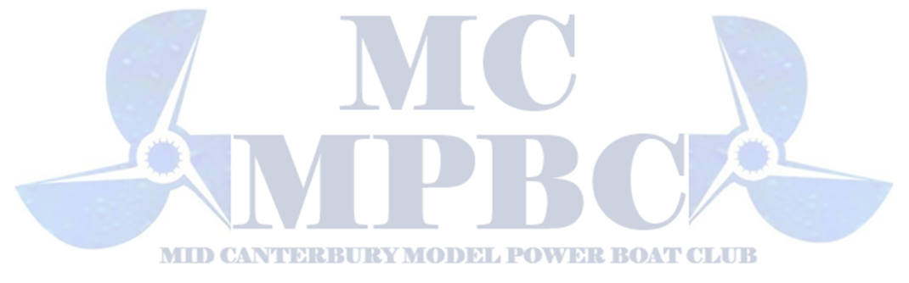
2026 Easter Nationals Entry Form

Event Dates: April 3-5th , 2026
Venue: Lake Hood, Ashburton
Entries Close: [Insert Closing Date]

Personal Details
Full Name | ____________________________
NZMPBA Membership Number | ____________________________
Address | ____________________________
Phone Number | ____________________________
Email Address | ____________________________
Emergency Contact Name / Phone | ____________________________

Class Entries
(Please tick the classes you wish to enter)
✓ | Class
☐ | King of the Lake
☐ | Open Hydro
☐ | Open Tunnel
☐ | Open Mono
☐ | Sport Petrol Hydro
☐ | T1 Thunder Boat
☐ | Stock Mono
☐ | Open Electric
☐ | Crackerbox
☐ | Q6s Open
☐ | P 4S Open
☐ | Open Nitro
☐ | Petrol Out Rigger

Fees
Entry Fee $35 | $_____
Entry Fee per Class $5 | $______
Nationals Tee Shirt $50  Nationals Iron on Transfer’s $30 | $_____ Size _____  $_____ Available to Iron on your Own Shirt/Hoodie/Bag etc
Event Dinner Sunday 5th $45 | $_____
Or Package Deal –  Includes Entry Fee + Unlimited Classes + Tee Shirt + Dinner $140 | $_______
Total Enclosed | $__________

Please make payment to: NZMPBA ( 02-0600-0007986-002 )
Reference: Your Name + NZMPBA #
BBQ Breakfast, Tea, Coffee and lunch food will be available to purchase over the 3 Days

Declaration
I declare that all boats entered comply with NZMPBA rules and safety standards.
I agree to abide by the rules and directions of the event organizers and race officials.
I accept that photos of myself and boats maybe posted on social media
All Boats must clearly display your NZMPBA Number (Lage Decal Numbers are available to purchase at RC Parts RC Decals ) https://www.rcparts.co.nz/category/253730
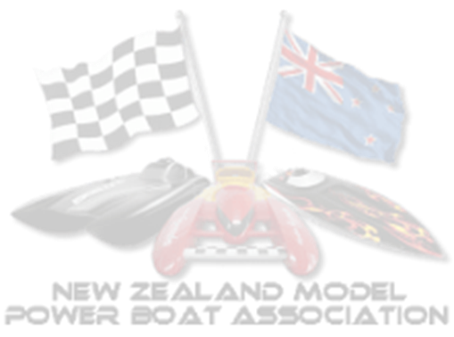
All boats must be fitted with a working Kill switch. These can also be purchased at RC Parts Dynamite Large Scale Safety Kill Switch - RC Car Parts RC Boats https://www.rcparts.co.nz/product/dynamite-large-scale-safety-kill-switch
Signature: ____________________________
Date: ___________________

Return Completed Entry Form To:
rclifeltd@gmail.com
Enquiries: Kara Steenhart 027 7272789

Lake Map + Link
https://maps.app.goo.gl/puBpyHiDibcqrFnG9
https://maps.app.goo.gl/k6roThN8mc6pDCL69
Signs will be posted from Lake Hood
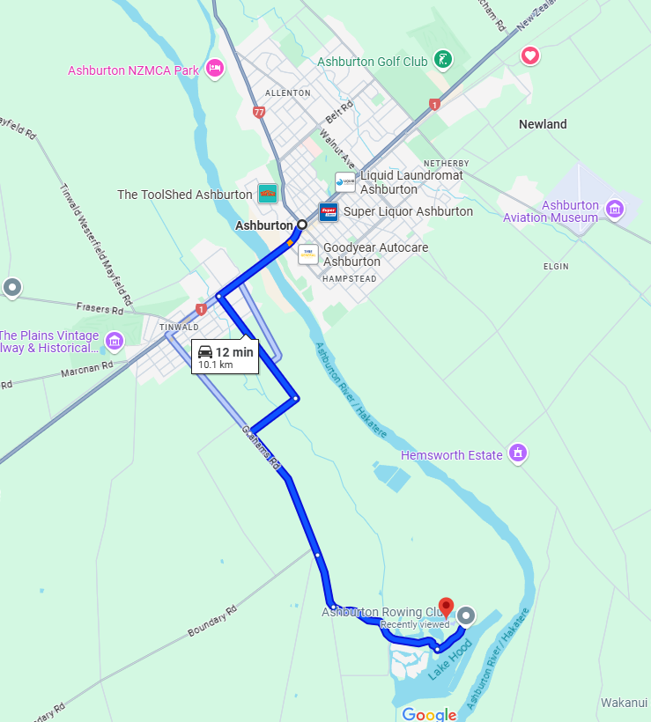
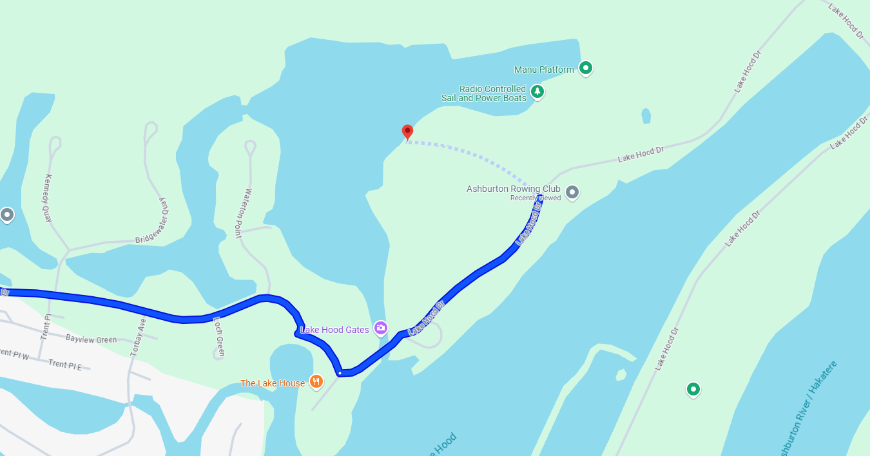

Tee Shirt

Tee Shirt will be Black with Logo below on the Back with Mid Canterbury Model Power Boat Club Logo.
On the Front Pocket Area will be the NZMPBA Logo

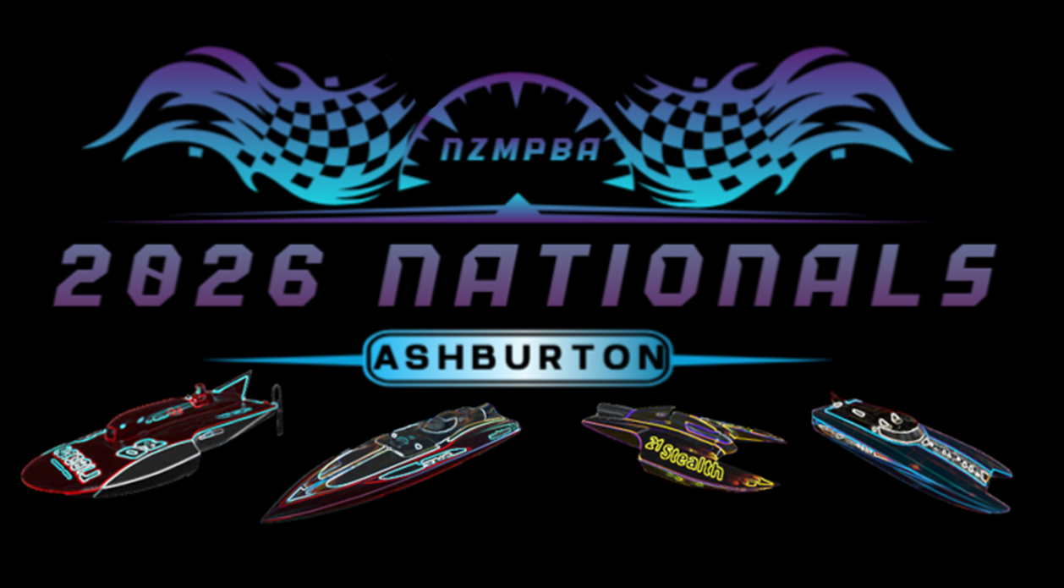
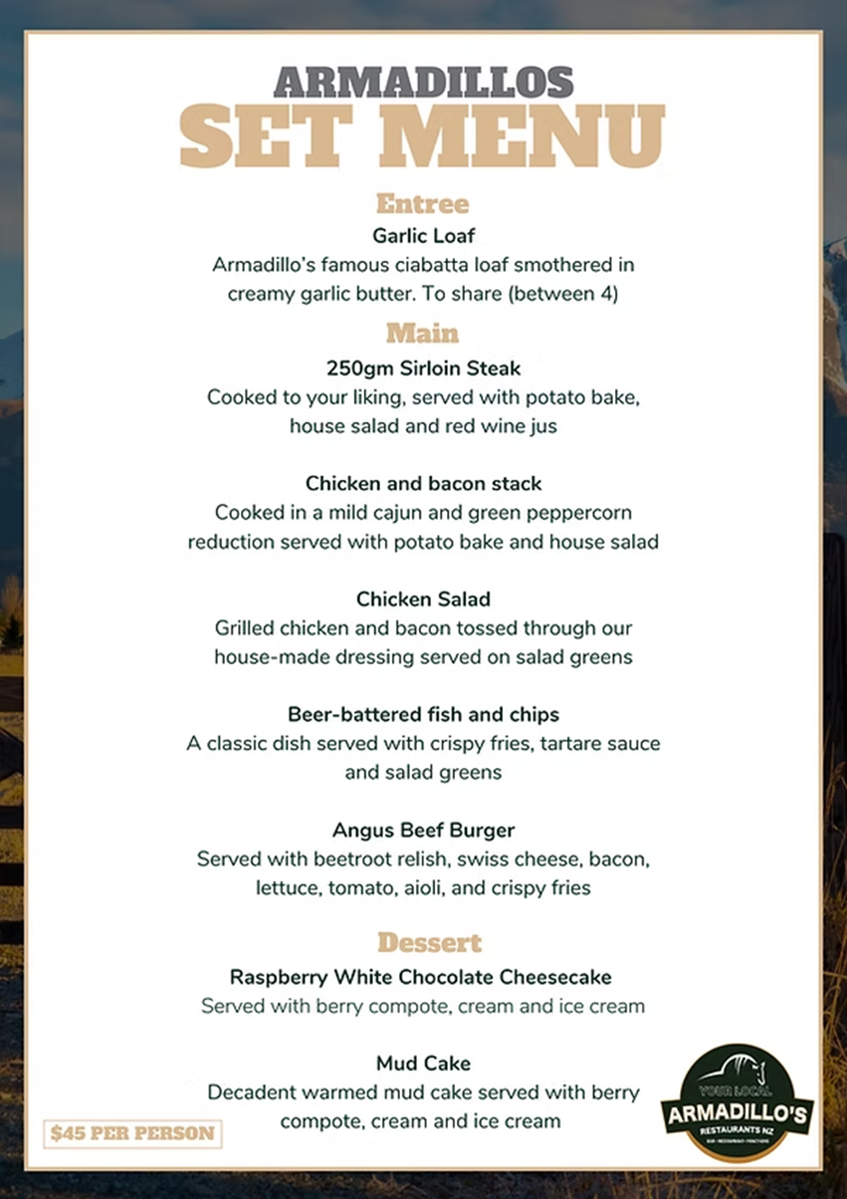

Some Accommodation Options Ashburton
Tinwald Motel
7km drive to Lake hood
Restaurant + Sports Bar + Liquor Store + Super Market All next door
Units from $145 per night
Ashburton Motel Accommodation | Tinwald Motel | Affordable Luxury
Ashburton Holiday Park & Lodge
Next Door to the Tinwald Domain with free access to Golf, Tennis & basketball Courts
8km Drive to Lake Hood
Family Cabins Shared facilities $85 per night
Studios from $135 Per night
Powered sites from $30 per night
Non Powered from $18 per night
Domain & Park Facilities - ASHBURTON HOLIDAY PARK & LODGE
Commodore Motor Lodge
12 km Drive to Lake Hood
Studios from $144 per night
Commodore Motor Lodge - Ashburton Motel Accommodation
Coronation Park Holiday Park
11km Drive to Lake Hood
Cabins from $75 per night
Powered sites from $20 Per night
Non Powered sites from $30 Per night
Coronation Park Motels & Holiday Park Ashburton, Canterbury

Canterbury Accommodation, Motel in Canterbury - Taylors Motel [Official Site]
The Suites: Affordable and Convenient Motel in Ashburton for Budget Travelers - Accommodation
Quality Ashburton Motel Accommodation | Bella Vista Motels NZ
Genuine Kiwi Hospitality | ASURE Adcroft Motel

